
The European Journal of Applied Economics
ISSN: 2406-2588
UDK
Original paper / Originalni naučni rad

TITLE OF THE MANUSCRIPT
Petar Petrović^{1,}*, Petar Petrović ²
¹ Singidunum University, Full professor
32 Danijelova Street, Belgrade, Serbia, ORCID: 0000-0002-6543-1472
² Singidunum University, Assistant Professor,
32 Danijelova Street, Belgrade, Serbia, ORCID: 0000-0001-8937-7135
*e-mail: ppetrovic@singidunum.ac.rs

Abstract:
An abstract must accompany every article. It should be a brief summary of the significant items of the main paper. The abstract should give concise information about the content of the core idea of your paper. It should be informative and not only present the general scope of the paper but also indicate the main results and conclusions. The abstract should not normally exceed 200 words. It should not contain literature citations or references to the tables or illustrations. All non-standard symbols and abbreviations should be defined. In combination with the title and keywords, the abstract is an indicator of the content of the paper. Authors should remember that online systems rely heavily on the content of titles and abstracts to identify articles in electronic bibliographic databases and search engines. They are therefore requested to take great care in preparing these elements.

Key words: Up to 5 key terms can be selected. We would suggest to avoid repeating the title.
Generally, a standard scientific paper is divided into the following sections:
- introduction,
- main text,
- conclusions.

Introduction

Authors present the subject of their paper clearly, indicate the scope of the subject, present the goals of their paper and finally the organization of the paper. Novelty of the presented research should be emphasized and the subject well documented in the up-to-date literature.

Main text

General rules for writing:
- use simple and declarative sentences, avoid long sentences, in which the meaning may be lost by complicated construction;
- be concise, avoid idle words;
- make your argumentation complete; use commonly understood terms; define all non-standard symbols and abbreviations when you introduce them;
- Latin words, as well as the names of species, should be in italic, as for example: i.e. or e.g.
- explain all acronyms and abbreviations when they first appear in the text.
Tables and figures and/or schemes should be embedded in the manuscript, and appropriately numbered and labelled.
Tables
Authors should use tables to achieve concise presentation or where the information cannot be given satisfactorily in other ways. Tables should be prepared with the aid of the Word table function, without vertical lines. The minimum size of the font in the tables should be 10 pt. Tables should not be incorporated as graphical objects. Styles and fonts should match those in the main body of the article. Tables should be placed in the text and should be numbered consecutively using Arabic numbers. Each table should have an explanatory caption which should be as concise as possible.

Table 1 - Review of the respondents that travelled for leisure in the period 2001/2004 per year (%).
Year | Respondents that  travelled only once | Total respondents  that travelled
2001 | 7.2 | 22.5
2002 | 10.3 | 25.5
2003 | 9.4 | 24.6
2004 | 9.0 | 24.2
Figures
Authors may use line diagrams to illustrate theses from their text. The figures should be clear, easy to read and of good quality. Styles and fonts should match those in the main body of the article. Lettering and lines should be of uniform density and the lines unbroken. Axis labels should be in bold face. Units should be placed next to variables in parentheses. Figures should be numbered consecutively using Arabic numbers.
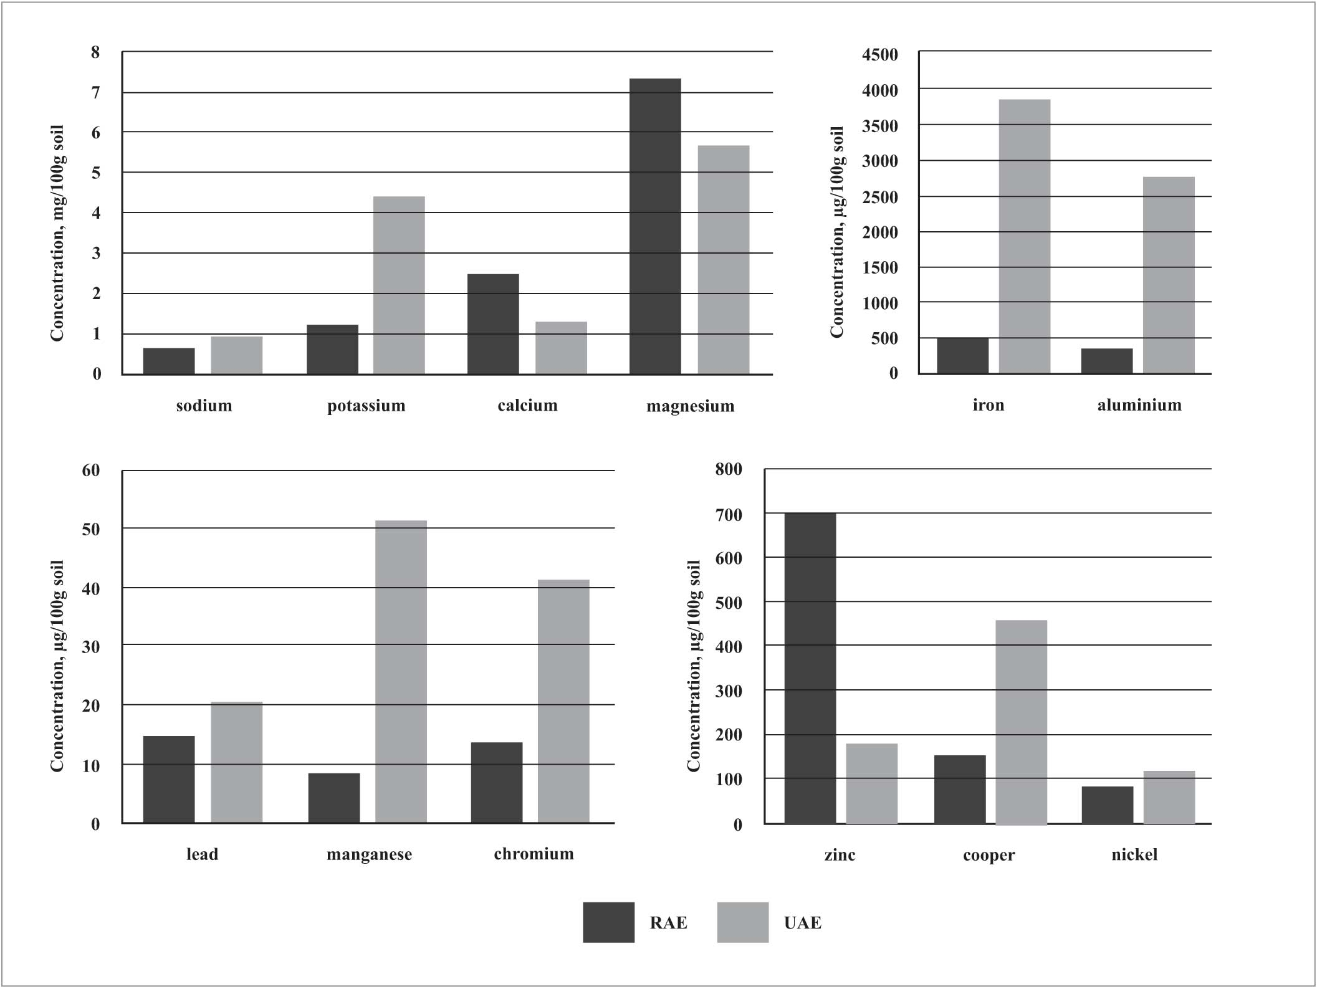
Figure 1 - A comparison of sample extraction procedures for the determination of inorganic anions in soil by ion chromatography.
Mathematical equations should be embedded in the text. Complex equations should be prepared with the aid of the Word Equation editor. All equations must be numbered using Arabic numbers consecutively in parenthesis at the end of the line, as presented:
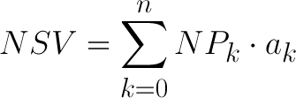 (1)
Footnotes/Endnotes/Acknowledgements: Number of footnotes is limited to 5. Information concerning research grant support or the assistance of colleagues should appear in a separate Acknowledgements section at the end of the paper, not in a footnote.

ConclusionS
Be brief and present the most important conclusions from your paper. Do not use equations and figures here.

References
- Book
  - Book (one author) format:
Example:
Baxter, R. J. (2016). Exactly solved models in statistical mechanics. Elsevier.

  - Book (two or more authors) format:
Example:
Bodie, Z., Kane, A., & Marcus, A. J. (2015). Portfolio management. McGraw Hill/Learning Solutions.

  - Republished book, with editor
Example:
Watson, J. B., & Rayner, R. (2013). Conditioned emotional reactions: The case of Little Albert (D. Webb, Ed.). CreateSpace Independent Publishing Platform. http://a.co/06Se6Na (Original work published 1920)

  - Chapter in an edited book
Example:
Dillard, J. P. (2020). Currents in the study of persuasion. In M. B. Oliver, A. A. Raney, & J. Bryant (Eds.), Media effects: Advances in theory and research (4th ed., pp. 115–129). Routledge.

  - Conference presentation
Example:
Evans, A. C., Jr., Garbarino, J., Bocanegra, E., Kinscherff, R. T., & Márquez-Greene, N. (2019, August 8–11). Gun violence: An event on the power of community[Conference presentation]. APA 2019 Convention, Chicago, IL, United States. https://convention.apa.org/2019-video

  - Abstract of a conference presentation
Example:
Cacioppo, S. (2019, April 25–28). Evolutionary theory of social connections: Past, present, and future [Conference presentation abstract]. Ninety-ninth annual convention of the Western Psychological Association, Pasadena, CA, United States. https://westernpsych.org/wp-content/uploads/2019/04/WPA-Program-2019-Final-2.pdf

  - Conference proceedings published in a journal
Example:
Duckworth, A. L., Quirk, A., Gallop, R., Hoyle, R. H., Kelly, D. R., & Matthews, M. D. (2019). Cognitive and noncognitive predictors of success. Proceedings of the National Academy of Sciences, USA, 116(47), 23499–23504. https://doi.org/10.1073/pnas.1910510116

  - Conference proceedings published as a whole book
Example:
Kushilevitz, E., & Malkin, T. (Eds.). (2016). Lecture notes in computer science: Vol. 9562. Theory of cryptography. Springer. https://doi.org/10.1007/978-3-662-49096-9

  - Conference proceedings published as a book chapter
Example:
Bedenel, A.-L., Jourdan, L., & Biernacki, C. (2019). Probability estimation by an adapted genetic algorithm in web insurance. In R. Battiti, M. Brunato, I. Kotsireas, & P. Pardalos (Eds.), Lecture notes in computer science: Vol. 11353. Learning and intelligent optimization (pp. 225–240). Springer. https://doi.org/10.1007/978-3-030-05348-2_21

  - Published Dissertation or Thesis References
Example:
Zambrano-Vazquez, L. (2016). The interaction of state and trait worry on response monitoring in those with worry and obsessive-compulsive symptoms [Doctoral dissertation, University of Arizona]. UA Campus Repository. https://repository.arizona.edu/handle/10150/620615

- Article
  - Journal Article
Example:
Gajić, J. (2012). Importance of marketing mix in higher education institutions. The European Journal of Applied Economics, 9(1), 29-41.

  - Monograph as Part of a Journal Issue
Example:
Ganster, D. C., Schaubroeck, J., Sime, W. E., & Mayes, B. T. (1991). The nomological validity of the Type A personality among employed adults [Monograph]. Journal of Applied Psychology, 76(1), 143–168. http://doi.org/10.1037/0021-9010.76.1.143

- Other formats
  - Web page on a Website References
Example:
Bologna, C. (2019, October 31). Why some people with anxiety love watching horror movies. HuffPost. https://www.huffpost.com/entry/anxiety-love-watching-horror-movies_l_5d277587e4b02a5a5d57b59e

  - Report by a Government Agency References
Example:
Taking time: Support for people with cancer (NIH Publication No. 18-2059). U.S. Department of Health and Human Services, National Institutes of Health. https://www.cancer.gov/publications/patient-education/takingtime.pdf

  - Dataset References
Example:
O’Donohue, W. (2017). Content analysis of undergraduate psychology textbooks (ICPSR 21600; Version V1) [Data set]. ICPSR. https://doi.org/10.3886/ICPSR36966.v1

  - Whole Website References
Example:
We created our survey using Qualtrics (https://www.qualtrics.com).

